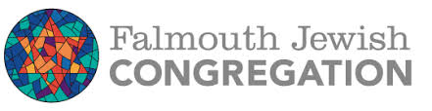
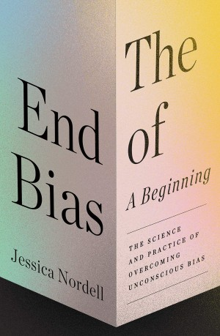
"Jessica Nordell’s powerful book is a breakthrough. With state-of-the-art science and gripping narratives, she reveals what concrete steps individuals, groups, and institutions can take to fight prejudice.” ―Adam Grant, author of Think Again: The Power of Knowing What You Don't Know and host of the TED podcast WorkLife
Named a Best Book of the Year by World Economic Forum, AARP, Greater Good, and Inc.
A Jewish Book Council Author Talk by Jessica Nordell on The End of Bias
Thursday, October 13 at 7PM
Register at: https://www.falmouthjewish.org
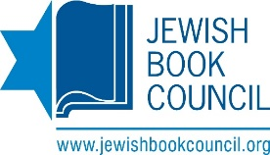 Books are available for purchase from

